32.

#include <iostream>

using namespace std;

int main ()

{ char ch87078634=0; //entered_character;

int ch87078634_val=0; //respective_ACSI_value_of_the_character;

cout<<"Please_input_any_character: ";//input_the_data

cin>>ch87078634;

ch87078634_val=ch87078634;

if (ch87078634_val>=33 && ch87078634_val<=47 || ch87078634_val>=58 && ch87078634_val<=64 || ch87078634_val>=91 && ch87078634_val<=96 || ch87078634_val>=123 && ch87078634_val<=126)

//condition_for_the_special_symbols;

{

cout<<"Special_symbol\n";

}

if (ch87078634_val>=48 && ch87078634_val<=57) //condition_for_the_numbers

{

cout<<"_Number_\n";

}

if (ch87078634_val>=65 && ch87078634_val<=90) //condition_for_capital_letter;

{

cout<<"The_capital_letter\n";

}

if (ch87078634_val>=97 && ch87078634_val<=122) //condition_statement_for_the_small_letter

{

cout<<"The_small_letter\n";

}

return 0;

}

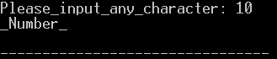

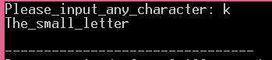

33.

#include <iostream>

using namespace std;

int main ()

{

//to_store_the_integer_number

int input_SM;

//display_the_question

cout<<"Please,_enter_any_integer_number: ";

//input_data

cin>>input_SM;

//if_function_condition

if (input_SM%2==0)

{

//output_for_even

cout <<input_SM<<" is_EVEN_NUMBER!\n";

}

//for_other_cases

else

{

//output_for_odd

cout<<input_SM<<" is_ODD_NUMBER!\n";

}

return 0;

}

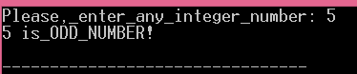

34.

#include <iostream>

using namespace std;

int main ()

{

int peop_870786; //for_the_people

int car_870786; // for_the_cars

int bus_870786; // for_buses

cout<<"Hello!_Please,_input_the_number_of_People: ";

cin >> peop_870786;

cout<<endl;

cout<<"Please,_input_the_amount_of_cars: ";

cin>> car_870786;

cout<<endl;

cout<<"Please,_input_the_amount_of_busses: ";

cin>> bus_870786;

cout<<endl;

//here_I_start_if_else_loop

if (car_870786>peop_870786)

{

cout<<"We_SHOULD_take_the_cars!\n";

}

//else_if_function_gives_opportunity_to_define_more_conditions

if (car_870786<peop_870786)

{

cout<<"We_SHOULD_NOT_take_the_cars!\n";

}

//another else if

if (car_870786==peop_870786)

{

cout<<"We_CANNOT_decide!\n";

}

if (bus_870786>car_870786)

{

cout<< "That_is_too_many_buses!\n";

}

if (bus_870786<car_870786)

{

cout<<"Maybe_we_COULD_take_the_buses!\n";

}

if (bus_870786==car_870786)

{

cout<<"We_still_CANNOT_decide!\n";

}

if (peop_870786>bus_870786)

{

cout<<"All_right_LET_us_just_take_buses!\n";

}

if (peop_870786<=bus_870786)

{

cout<<"Fine_LET_us_stay_home_then!\n";

}

return 0;

}

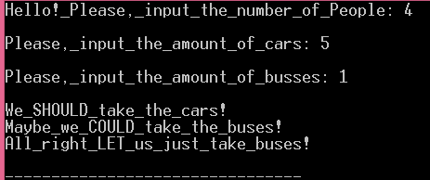

35. //35

#include <iostream>

using namespace std;

int main ()

{

//variable declarations

double Gross870786, HRA870786, DA870786, sal870786;

//ask to input information;

cout<<"Hello! Please, input your salary in dollars: ";

cin>>sal870786;

cout<<"\n";

//start conditions with if else loop

if (sal870786<1500)

{

HRA870786=0.1*sal870786; //determination of HRA

DA870786=0.9*sal870786; //determination of DA

Gross870786=sal870786+HRA870786+DA870786; //Determination of gross

cout<<Gross870786;

}

//another if condition

if (sal870786>=1500)

{

HRA870786=500; //determination of HRA

DA870786=0.98*sal870786; //determination of DA

Gross870786=sal870786+HRA870786+DA870786; //Determination of gross

cout<<Gross870786;

}

return 0;

}

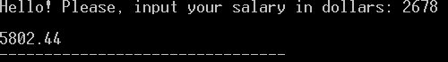

36. //36

#include <iostream>

using namespace std;

int main ()

{

//variable declarations with double type

double Far870786, Cel870786, choice870786;

//ask to select between converters

cout << "Please_select_which_converter_you_prefer: \n";

cout<<"_Fahrenheit-> _Celsius - select 1\n";

cout<<"_Celsius -> _Fahrenheit - select 2\n";

cin>>choice870786;

//begin if condition loop;

if (choice870786==1) //F to C converter;

{

cout<<"Input_temperature in F: ";

cin>>Far870786;

cout<<endl;

Cel870786=(Far870786-32)*5/9;

cout<<Cel870786;

}

if (choice870786==2) //C to F converter;

{

cout<<"Input_tempeature in C: ";

cin>>Cel870786;

cout<<"\n";

Far870786=Cel870786*9/5+32;

cout<<Far870786;

}

return 0;

}

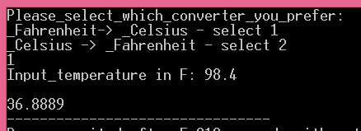

37.

#include <iostream>

#include <cctype> //for_charters_analysis

using namespace std;

int main ()

{ char input87078634[100]={0}; //input_text_storage;

cout<<"Please_enter_the_text: ";

cin.getline(input87078634, 100); //input_text;

int n87078634=0;

for (int i8634=0; input87078634[i8634] !='\0'; i8634++)

if (std::islower(input87078634[i8634])){

n87078634=n87078634+1; } //here_it_counts_number_of_small_letters

if (n87078634>0) //if_there_are_any_small_letter

{ cout<<"_INVALID_"; }

else

{cout<<"_VALID_"; }

return 0;}

C:\Users\Admin\AppData\Local\Microsoft\Windows\INetCache\Content.Word\Новый рисунок.bmp

C:\Users\Admin\AppData\Local\Microsoft\Windows\INetCache\Content.Word\Новый рисунок.bmp

38. //38

#include <iostream>

using namespace std;

int main ()

{

int n87078634;//number_entered

int a87078634=0; //first_member

int b87078634=1; //second_member

int n_fol87078634, i; //n87078634 -the_following_members

cout<<"Input_the_number: ";

cin>>n87078634;

cout <<a87078634<<" "<<b87078634<<" "; //for_displaying_starting from_this numbers

for (i=1; i<n87078634-1; i++){ //I open the for loop

n_fol87078634=a87078634+b87078634; //determination of the following term

a87078634=b87078634; //shows that_in next time first term_becomes the second term

b87078634=n_fol87078634; //shows_that in_repeated_operation the_second_becomes the sum of first two terms

cout <<n_fol87078634<<" "; //displaying_the_results

}

return 0;

}

C:\Users\Admin\AppData\Local\Microsoft\Windows\INetCache\Content.Word\Новый рисунок.bmp

C:\Users\Admin\AppData\Local\Microsoft\Windows\INetCache\Content.Word\Новый рисунок (1).bmp

39. //39

#include <iostream>

using namespace std;

int main ()

{

int ag187078634, ag287078634, ag387078634, sum87078634;//input

cout<<"Please_input_three_angles: ";

cin>>ag187078634;//1st_angle

cout<<endl;

cin>>ag287078634;//2nd_angle

cout<<endl;

cin>>ag387078634;//3rd_angle

cout<<endl;

sum87078634=ag187078634+ag287078634+ag387078634;

//condition_statement_if

if (sum87078634<180){

cout<<"YES!\n";

} else { cout <<"NO!";

}

}

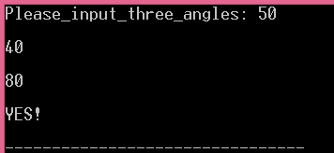

40.

#include <iostream>

using namespace std;

int main ()

{

int rev87078634=0;

int nb87078634; //input

cout <<"Please_input_the_number: ";

cin>>nb87078634;

cout<<endl;

int store87078634=nb87078634; //to_store_the_original_one

while (nb87078634>0)//while_loop_starts_for_defining_reverse_input

{ rev87078634=nb87078634%10+rev87078634*10;//defines_the_reversed_of_the_original_number

nb87078634=nb87078634/10;//every_step_the_input_is_divided_by 10;

}

//if_else_conditions

if (store87078634==rev87078634){

cout<<"It_is_Palindrome_number!\n";

}

else { cout<<"It_is_NOT_Palindrome_number!\n";

}

return 0;

}

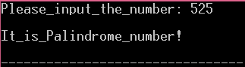

41. //41

#include <iostream>

using namespace std;

int main ()

{

int nb87078634; //entered data;

cout<<"Enter number: \n";

cin>>nb87078634;

cout<<endl;

//I start if condition here

if (nb87078634>0){ //accepts only positive numbers!

if (nb87078634!=2 && nb87078634!=3 && nb87078634!=5 && nb87078634!=7)

{ if (nb87078634%7==0 | nb87078634%5==0 | nb87078634%2==0 | nb87078634%3==0){

cout<<"0\n";

}

else { //if it is equal to 2, 3, 5, 7

cout<<"1\n";

}

}

else

cout << "1\n";

}

return 0;

}

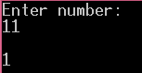 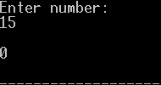

42. //42

#include <iostream>

using namespace std;

int main ()

{ int nb187078634; //1st input;

int nb287078634; //2nd input

int ans87078634; //answer

cout<<"Input 2 numbers: ";

cin>>nb187078634;

cout<<endl;

cin>>nb287078634;

cout<<endl;

//here the ternary operators start

ans87078634=(nb187078634>nb287078634 | nb187078634==nb287078634)?nb187078634:nb287078634;

cout <<ans87078634<<endl;

return 0;

}

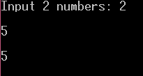

43. //43

#include <iostream>

using namespace std;

int main ()

{

int nb87078634; //declaration

cout<<"Enter_the_weeks's_day_from_1_to_7: \n"; //asks_to_enter_the_data

cin>>nb87078634; //store_the_input_value

cout<<endl;

if (nb87078634==1){

cout<<"_Sunday_";}

if (nb87078634==2){

cout<<"_Monday_";}

if (nb87078634==3){

cout<<"_Tuesday_";}

if (nb87078634==4){

cout<<"_Wednesday_";}

if (nb87078634==5){

cout<<"_Thursday_";}

if (nb87078634==6){

cout<<"_Friday_";}

if (nb87078634==7){

cout<<"_Saturday_";}

return 0;

}

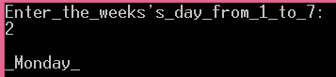

44. //44

#include <iostream>

using namespace std;

int main ()

{

int nb187078634; //1st number;

int nb287078634; // 2nd number;

int nb387078634; //2rd number

cout <<"Enter three number: \n";

cin>>nb187078634;

cout<<endl;

cin>>nb287078634;

cout<<endl;

cin>>nb387078634;

cout<<endl;

if (nb187078634>nb287078634 && nb187078634>nb387078634)

{cout <<"Output: "<<nb187078634<<endl;}

if (nb187078634<nb287078634 && nb287078634>nb387078634)

{cout <<"Output: "<<nb287078634<<endl;}

if (nb187078634<nb387078634 && nb287078634<nb387078634)

{cout <<"Output: "<<nb387078634<<endl;}

return 0;

}

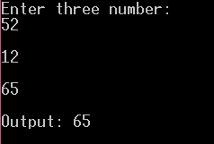

45.

//45

#include <iostream>

using namespace std;

int main ()

{

double earth_87078634; // earth's_mass;

int choice_87078634; //for_planet_choosing_desicion

double weight_87078634; //calculated_weight

cout<<"Please_ENTER_Mass_on_the_Earth_(pounds): "; //entered data

cin>>earth_87078634;

cout<<endl;

cout<<"Venus____1____________Mars___2_____________Jupiter__3\n";

cout<<"Saturn___4____________Uranus___5___________Neptune__6\n";

cout<<"Make a choice: ";

cin>>choice_87078634;

cout <<endl;

//all_condition_statement_intended_to_define_the_value_of_gravity_constants

if (choice_87078634==1){

weight_87078634=0.78*earth_87078634; }//defining_equation}

else if (choice_87078634==2){

weight_87078634=0.39*earth_87078634;} //defining_equation}

else if (choice_87078634==3){

weight_87078634=2.65*earth_87078634; }//defining_equation}

else if (choice_87078634==4){

weight_87078634=1.17*earth_87078634; }//defining_equation}

else if (choice_87078634==5){

weight_87078634=1.05*earth_87078634; }//defining_equation}

else if (choice_87078634==6){

weight_87078634=1.23*earth_87078634; }//defining_equation}

cout<<"The_weight_on_that_planet: "<<weight_87078634<<endl;

return 0;

}

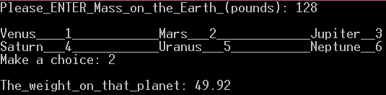

46.

#include <iostream>

using namespace std;

int main ()

{

char name_87078634[100];

int age_87078634;

cout<<"Please_ENTER_your_name: ";

cin>>name_87078634;

cout<<endl;

cout<<"Please_ENTER_your_age: ";

cin>>age_87078634;

cout<<endl;

if (age_87078634>16)

{

if (age_87078634>18)

{

if (age_87078634>25) {

cout<<"You_can_do_anything_legal "<<name_87078634<<"!\n" }

else

{ cout<<"You_cannot_rent_a_car "<<name_87078634<<"!\n";

} }

else

{ cout<<"You_cannot_vote "<<name_87078634<<"!\n";

cout<<"You_cannot_rent_a_car "<<name_87078634<<"!\n"; }

}

else

{ cout << "You_cannot_drive "<<name_87078634<<"!\n";

cout<<"You_cannot_vote "<<name_87078634<<"!\n";

cout<<"You_cannot_rent_a_car "<<name_87078634<<"!\n"; }

return 0;

}

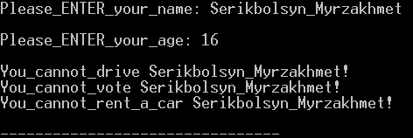

47.

#include <iostream>

using namespace std;

int main ()

{

int year_8634, date_8634, month_8634; //input_data;

int total_date_8634; //converted_day_number;

cout<<"Please_ENTER_any_year_greater_than_1900_in_4_digits: ";

cin>>year_8634;

cout<<endl;

cout<<"enter_month: ";

cin>>month_8634;

cout<<"\nenter_date: ";

cin>>date_8634;

cout<<"\n";

int num_leap_8634;

num_leap_8634=(year_8634-1900)/4; //I_calculate_the_number_of_leap_years_between_entered_year_and_1900

int datef_8634; //the_number_of_dates_from_the_beginning_of_the_year

if (year_8634%4==0 && year_8634%100!=0 || year_8634%400==0) //if_the_year_is_leap

{

//conditions_for_each_month:

if (month_8634==1){ datef_8634=date_8634; }

if (month_8634==2){ datef_8634=date_8634+31; }

if (month_8634==3){ datef_8634=date_8634+60; }

if (month_8634==4){ datef_8634=date_8634+91; }

if (month_8634==5){ datef_8634=date_8634+121; }

if (month_8634==6){ datef_8634=date_8634+152; }

if (month_8634==7){ datef_8634=date_8634+182; }

if (month_8634==8){ datef_8634=date_8634+213; }

if (month_8634==9){ datef_8634=date_8634+244; }

if (month_8634==10){ datef_8634=date_8634+274; }

if (month_8634==11){ datef_8634=date_8634+305; }

if (month_8634==12){ datef_8634=date_8634+335; }

}

else //for_all_other_cases;

{

//conditions_for_each_month:

if (month_8634==1){ datef_8634=date_8634; }

else if (month_8634==2){ datef_8634=date_8634+31; }

else if (month_8634==3){ datef_8634=date_8634+59; }

else if (month_8634==4){ datef_8634=date_8634+90; }

else if (month_8634==5){ datef_8634=date_8634+120; }

else if (month_8634==6){ datef_8634=date_8634+151; }

else if (month_8634==7){ datef_8634=date_8634+181; }

else if (month_8634==8){ datef_8634=date_8634+212; }

else if (month_8634==9){ datef_8634=date_8634+243; }

else if (month_8634==10){ datef_8634=date_8634+273; }

else if (month_8634==11){ datef_8634=date_8634+304; }

else if (month_8634==12){ datef_8634=date_8634+334; }

}

total_date_8634=((year_8634-1900)-num_leap_8634)*365+num_leap_8634*366+(datef_8634); //I_calculate_total_days;

//DISPLAYING_the_results:

if ((total_date_8634-1)%7==0)

{cout<<"_MONDAY_"; }

else if ((total_date_8634-1)%7==1)

{cout<<"_TUESDAY_"; }

else if ((total_date_8634-1)%7==2)

{cout<<"_WEDNESDAY_"; }

else if ((total_date_8634-1)%7==3)

{cout<<"_THURSDAY_"; }

else if ((total_date_8634-1)%7==4)

{cout<<"_FRIDAY_"; }

else if ((total_date_8634-1)%7==5)

{cout<<"_SATURDAY_"; }

else if ((total_date_8634-1)%7==6)

{cout<<"_SUNDAY_"; }

return 0;

}

}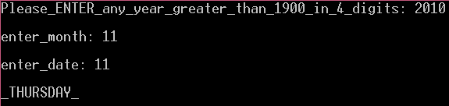

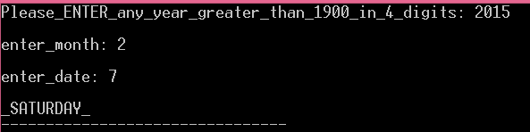

48. //48

#include <iostream>

using namespace std;

int main ()

{ int ar_87078634[5]; //iputted_array;

cout<<"Please_ENTER_5_numbers: ";

//for_loop_starts:

for (int i=1; i<6; ++i)

{

cin>>ar_87078634[i];

}

cout<<"Array_is: ";

for (int i=1; i<6; ++i)

{

cout<<ar_87078634[i];

}

return 0;

}

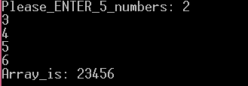

49.

#include <iostream>

using namespace std;

int main ()

{ int num_87078634=0, sum_87078634=0; //number_declaration;

//while_loop_starts_here:

while (num_87078634>=0 | num_87078634<0)

{

cout<<"The_total_so_far: "; //declares_total_sum

cout<<sum_87078634<<endl;

cout<<"Please_ENTER_numbers: ";

cin>> num_87078634;

sum_87078634=num_87078634+sum_87078634;

if (num_87078634==0){ break;

}

}

cout<<"The_total: "<<sum_87078634;

return 0;

}

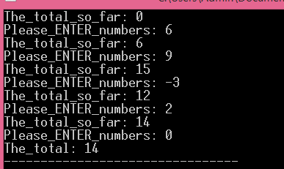

50.

//50

#include <iostream>

using namespace std;

int main ()

{ int num_87078634, av_87078634=0, a_87078634=0, count_87078634=0; //declaration_of_the_average_and_number;

do //loop_starts;

{

cout<<"enter_number: ";

cin>>num_87078634;

cout<<endl;

if (num_87078634!=0){ count_87078634=count_87078634+1; //count_of_the_numbers

}

a_87078634+=num_87078634;

av_87078634=a_87078634/count_87078634; //average_calculation_equation;

} while (num_87078634!=0);

cout<<"average_is: "<<av_87078634; //displays_output

return 0;

}

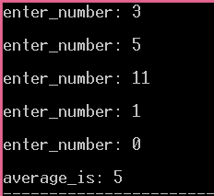

51. //51

#include <iostream>

using namespace std;

int main ()

{ int num_87078634;

int fac_87078634=1;

cout<<"input: ";

cin>>num_87078634;

while (num_87078634>0)

{

fac_87078634*=num_87078634;//factorial_determination

num_87078634=num_87078634-1;

} cout <<"Factorial_is: "<<fac_87078634;

return 0;

}

C:\Users\Admin\AppData\Local\Microsoft\Windows\INetCache\Content.Word\Новый рисунок.bmp

52.

//52

#include <iostream>

using namespace std;

int main ()

{ int nb_87078634=0, out_87078634; //entered_number;

cout<<"enter_the_number: ";

cin>>nb_87078634;

int a_87078634=0;

while (nb_87078634>0)

{

out_87078634=2+a_87078634; //every_time__adds;

cout<<out_87078634<<" ";

a_87078634=out_87078634;

nb_87078634=nb_87078634-1; //it_counts_till_number_is_0

if (nb_87078634==0)

{break; //then_finishes_the_loop

}}

return 0;

}

C:\Users\Admin\AppData\Local\Microsoft\Windows\INetCache\Content.Word\Новый рисунок.bmp

53. //53

#include <iostream>

using namespace std;

int main ()

{

int number_1_87078634; //I_declare_first_number;

int number_2_87078634; //second_number;

int hcf_87078634, n_87078634=1; //highest_common_factor_and_counter;

cout<<"Please_enter_the_numbers: ";

cin>>number_1_87078634;

cout<<endl;

cin>>number_2_87078634;

cout<<endl;

int a_87078634=0, b_87078634=0; //for_the_calculation_of_the_remainders

while (number_1_87078634!=0 && number_2_87078634!=0)

{

a_87078634=number_1_87078634%n_87078634;

b_87078634=number_2_87078634%n_87078634;

if (a_87078634==b_87078634 && a_87078634==0) //condition_statement_if_they_have_common_factor

{

hcf_87078634=n_87078634;

}

else if (n_87078634==number_1_87078634 || n_87078634==number_2_87078634 )

{

break;//breaks_the_loop_when_reached_max_count;

}

n_87078634=n_87078634+1;//every_time_it_adds_one_value_if_conditions_did_not_meet

}

cout<<endl<<"Highest_common_factor_is: "<<hcf_87078634;

return 0;}

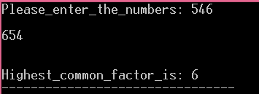

54. //54

#include <iostream>

using namespace std;

int main ()

{

int number_87078634, sum_87078634;

cout<<"enter_the_number: ";

cin>>number_87078634;

cout<<endl;

while (number_87078634>0)

{

sum_87078634+=number_87078634; //calculates_the_sum;

number_87078634=number_87078634-1; //every_step_substracts_one

}

cout<<"sum_is: "<<sum_87078634;

return 0;

}

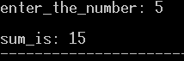

55.

#include <iostream>

using namespace std;

int main ()

{ double x_87078634=0, y_87078634, count=0; //_double_type_declaration;

while (x_87078634>=-10 && x_87078634<10) {

x_87078634=-10+count;

count=count+0.5;

y_87078634=x_87078634*x_87078634; //calculation_of_y;

cout<<x_87078634<<" "<<y_87078634<<endl;}

return 0;}

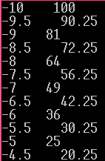

….

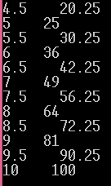

56.

#include <iostream>

using namespace std;

int main ()

{ const int length_8634=10;

int a_8634[length_8634];

for (int i8634=0; i8634<10; ++i8634) //first_for_loop_for_array_data_input;

{cout <<"Please_enter_the_index "<<i8634<<": ";

cin>>a_8634[i8634];

}

for (int i8707=0; i8707<10; ++i8707) //second_for_loop_for_defining_tripple_sums;

{

int l_8634=i8707+1; //starts_from_the_beginning;

int r_8634=length_8634-1; //starts_from_the_end_of_the_array

while (r_8634>l_8634)

{ //condition_if_to_check_every_time_the_tripple_sum;

if (a_8634[r_8634]+a_8634[l_8634]+a_8634[i8707]==0)

{

cout<<endl<<a_8634[i8707]<<" "<<a_8634[r_8634]<<" "<<a_8634[l_8634];

}

if (a_8634[r_8634]+a_8634[l_8634]+a_8634[i8707]>0)

{ r_8634=r_8634-1;} //

else

{l_8634=l_8634+1;}

}

}

return 0;

}

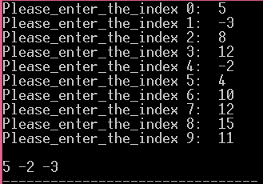

57. //57

#include <iostream>

using namespace std;

int main ()

{ int num_87078634; //input_number;

cout<<"Enter_the_number: ";

cin>>num_87078634;

cout<<endl<<"Collatz_sequense_is: \n";

while (num_87078634>0) {

if (num_87078634%2==0){ //if_condition_for_even_numbers;

num_87078634=num_87078634/2;

cout<< num_87078634<<endl;

}

if (num_87078634==1){ //when_the_number_will_be_1_the_loop_will_break;

break;

}

if (num_87078634%2!=0){ //if_codition_for_odd_numbers;

num_87078634=3*num_87078634+1;

cout<< num_87078634<<endl;

}

}

return 0;}

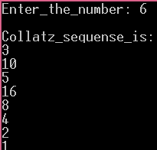

58.

#include <iostream>

using namespace std;

int main ()

{ int num_87078634=1; //value_declaration;

for (int i_8634=0; i_8634<20; ++i_8634)

{cout<<num_87078634; //displaying_results;

if (num_87078634%2==0) //condition_for_even_numbers_between_1_and_20

{ cout<<" <"<<endl;}

else

{ cout<<endl; }

num_87078634=num_87078634+1; //increment_till_20;

}

return 0;}

C:\Users\Admin\AppData\Local\Microsoft\Windows\INetCache\Content.Word\Новый рисунок.bmp

59.

//59

#include <iostream>

using namespace std;

int main ()

{ double x_87078634=0, count=0; //_double_type_declaration;

while (x_87078634>=-10 && x_87078634<10) {

x_87078634=-10+count;

count=count+0.5;

cout<<x_87078634<<endl;}

return 0;}

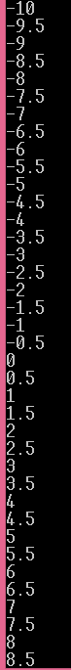

C:\Users\Admin\AppData\Local\Microsoft\Windows\INetCache\Content.Word\Новый рисунок.bmp

60.

//60

#include <iostream>

#include <cmath>

using namespace std;

int main ()

{ int num_87078634=100; //declare_armstrong_number;

int a_87078634, b_87078634, c_87078634, armstrong_87078634;

cout<<"Output_is: \n";

for (int i_8634=1; i_8634<900; ++i_8634)

{

a_87078634=num_87078634%10; //the_last_digit

b_87078634=((num_87078634-a_87078634)%100)/10; //the_second_digit;

c_87078634=((num_87078634-a_87078634-b_87078634*10))/100; //the_first_digit;

armstrong_87078634=pow(a_87078634,3)+pow(b_87078634,3)+pow(c_87078634,3);

if (armstrong_87078634==num_87078634){

cout<<num_87078634<<endl;

}

num_87078634=num_87078634+1; //adds_values_for_each_loop;

}return 0;}

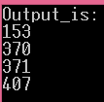

61. //61

#include <iostream>

using namespace std;

int main ()

{int a8634=0, b8634=0, c8634=0, d8634=0;

cout<<"The_output_numbers_are: ";

for (int i8634=0; i8634<45; ++i8634)

{

a8634=a8634+1; //I_define_the_first_number;

b8634=a8634+4; //I_define_the_second_number;

c8634=a8634/2+1; //I_define_the_third_number;

d8634=c8634*4; //I_define_the_fourth_number;

if (a8634+b8634+c8634+d8634==45)

{cout<<a8634<<" "<<b8634<<" "<<c8634<<" "<<d8634<<endl;}

}return 0;}

C:\Users\Admin\AppData\Local\Microsoft\Windows\INetCache\Content.Word\Новый рисунок.bmp

62.

//62

#include <iostream>

using namespace std;

int main ()

{

int num8634=0, num_28634=0, num_38634=0, num_48634=0;

for (int i8634=0; i8634<6; ++i8634) //_first_for_loop

{

cout<<"("<<num_28634<<" "<<num8634<<") "; //starts_from_value_(0_0);

num8634=num8634+1;

}

num_28634=1; //in_order_to_start_the_next_row_with_value_1;

for (int j8634=0; j8634<5; ++j8634) //second_for_loop;

{

num_48634=num_48634+1;

cout<<endl<<"("<<num_48634<<" "<<num_38634<<") ";

num8634=1;

for (int i8634=0; i8634<5; ++i8634) //third_loop_inside_second

{

cout<<"("<<num_28634<<" "<<num8634<<") ";

num8634=num8634+1;

}

num_28634=num_28634=num_28634+1;

}

return 0;}

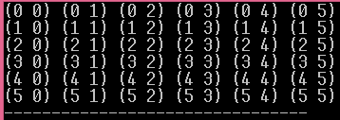

63.

#include <iostream>

using namespace std;

int main ()

{

int num8634=1, n8634; //n8634_is_the_stored_value_for_"-"_sign

n8634=4;

int h8634=1; //stored_value_for_the_amount_of_displayed_numbers;

for (int j8634=0; j8634<5; ++j8634) //first_for_loop_for_number_of_lines;

{

for (int i8634=n8634; i8634>0; --i8634) //for_loop_for_the_number_of_"-"_signs;

{

cout<<"-";}

for(int k8634=0; k8634<h8634; ++k8634) //for_the_number_of_displayed_numbers;

{cout<<num8634;

}

h8634=h8634+2;

num8634=num8634+1;

cout<<endl;//from_here_starts_new_line;

n8634=n8634-1;

}

return 0;}

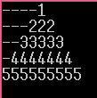

64.

#include <iostream>

using namespace std;

int main ()

{

int num87078634, h8634=1 ; //stored_value_of_input_number;

//value_h8634_is_for_storage_of_number_of_"-"_signs_for_each_line

cout<<"Please_enter_the_number_N: ";

cin>>num87078634; //input_store

int e8634=num87078634-1; //I_stored_the_value_of_entered_number_minus_1;

cout<<endl;

for(int z8634=0; z8634<num87078634; ++z8634 ) //for_displaying_first_line;

{

cout<<"*";

}

cout<<endl;

for (int f8634=0; f8634<num87078634-1; ++f8634) //for_displaying_the_rest_lines;

{

for (int i8634=0; i8634<h8634;++i8634 )

{

cout<<"-";

}

for (int d8634=e8634; d8634>0; --d8634)

{

cout<<"*";

}

cout<<endl;

h8634=h8634+1; //every_step_increases;

e8634=e8634-1; //every_step_decreases;

}

return 0;}

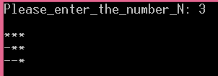

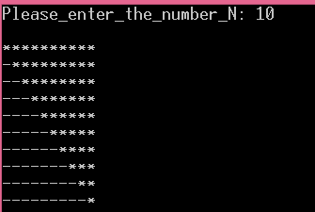

65.

#include <iostream>

using namespace std;

int main ()

{

int num8634, n8634, d8634=1; //n8634_is_the_stored_value_for_"-"_sign

n8634=4;

int h8634=1; //stored_value_for_the_amount_of_displayed_numbers;

for (int j8634=0; j8634<5; ++j8634) //first_for_loop_for_number_of_lines;

{

for (int i8634=n8634; i8634>0; --i8634) //for_loop_for_the_number_of_"-"_signs;

{

cout<<"-";}

num8634=d8634;

for(int k8634=0; k8634<h8634; ++k8634) //for_the_number_of_displayed_numbers;

{cout<<num8634;

num8634=num8634-1; //the_numbers_decrease_till_1_in_the_middle

}

if (h8634!=1) //skips_the_first_line_

{num8634=num8634+1;

for(int s8634=0; s8634<h8634-1; ++s8634) //loop_for_the_half_of_the_pyramid;

{ num8634=num8634+1; //the_numbers_increase_till_the_returning_to_previous_value;

cout<<num8634;

}

}

h8634=h8634+1;

d8634=d8634+1;

cout<<endl;//from_here_starts_new_line;

n8634=n8634-1;

}

return 0;}

